MACH4METAL

metalworking machinery
Transito 21, 6909 DA Babberich, Netherlands
Tel. + 31 (0)316 – 247123
Fax. + 31 (0)316 - 247956
info@mach4metal.com
www.mach4metal.com
Bank No : 66.52.13.883
IBAN : NL33 INGB 0665 2138 83
BIC : INGBNL2A
VAT : NL 815393635B01

MFD HOESCH Rail – Way Lathe

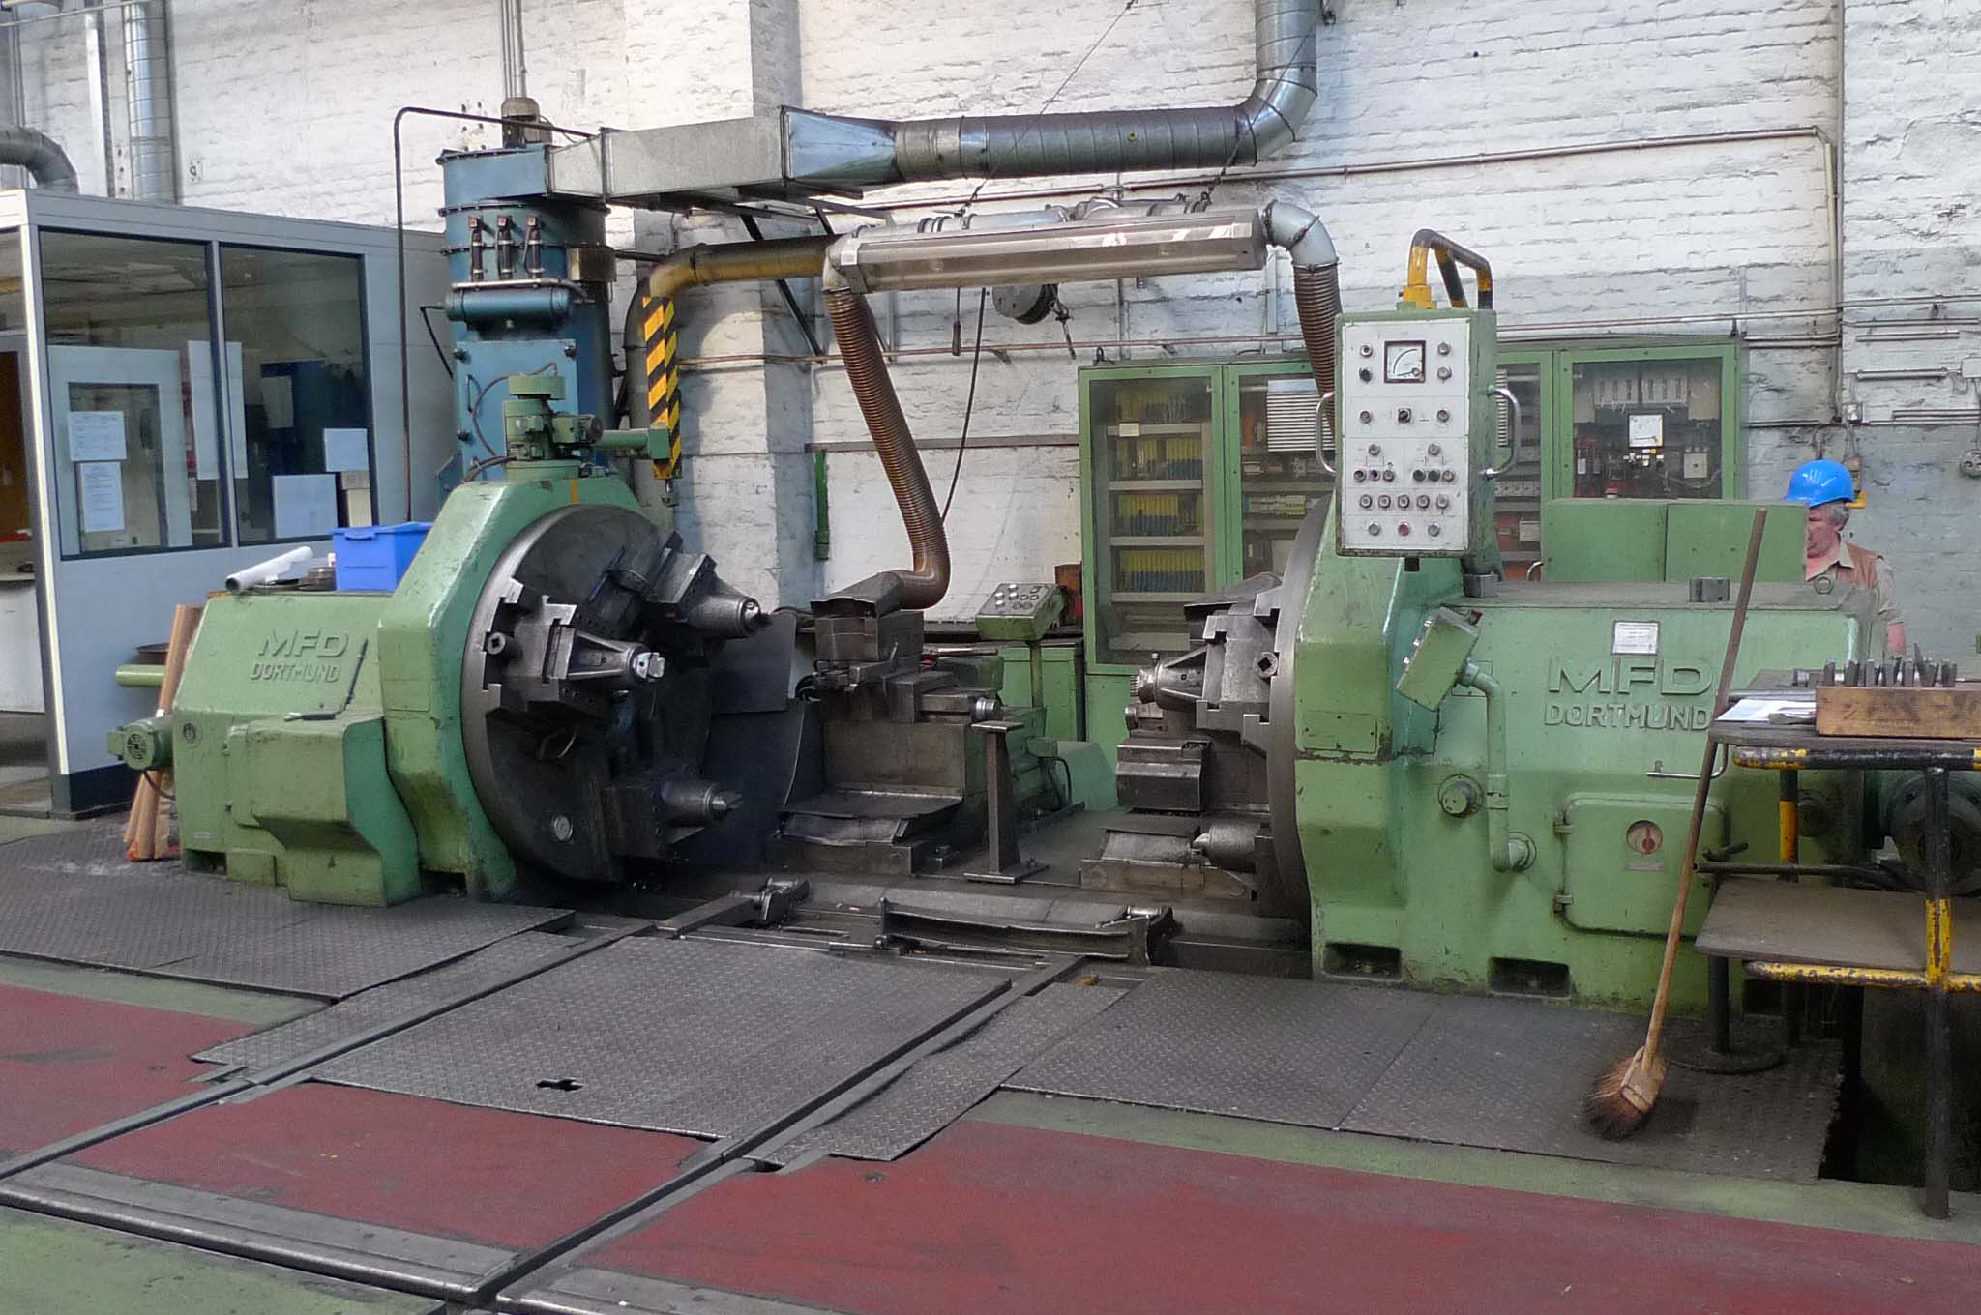
- Make MFD HOESCH - Germany
- Typ DRH 130 II – K - S
- Age 1965
- Mach.No. s/n100562

- Height of centers : 800
- Rail track gauge : 1.435

- Max. wheel tread Ø. : 1.350
- Min. wheel tread Ø. : 750
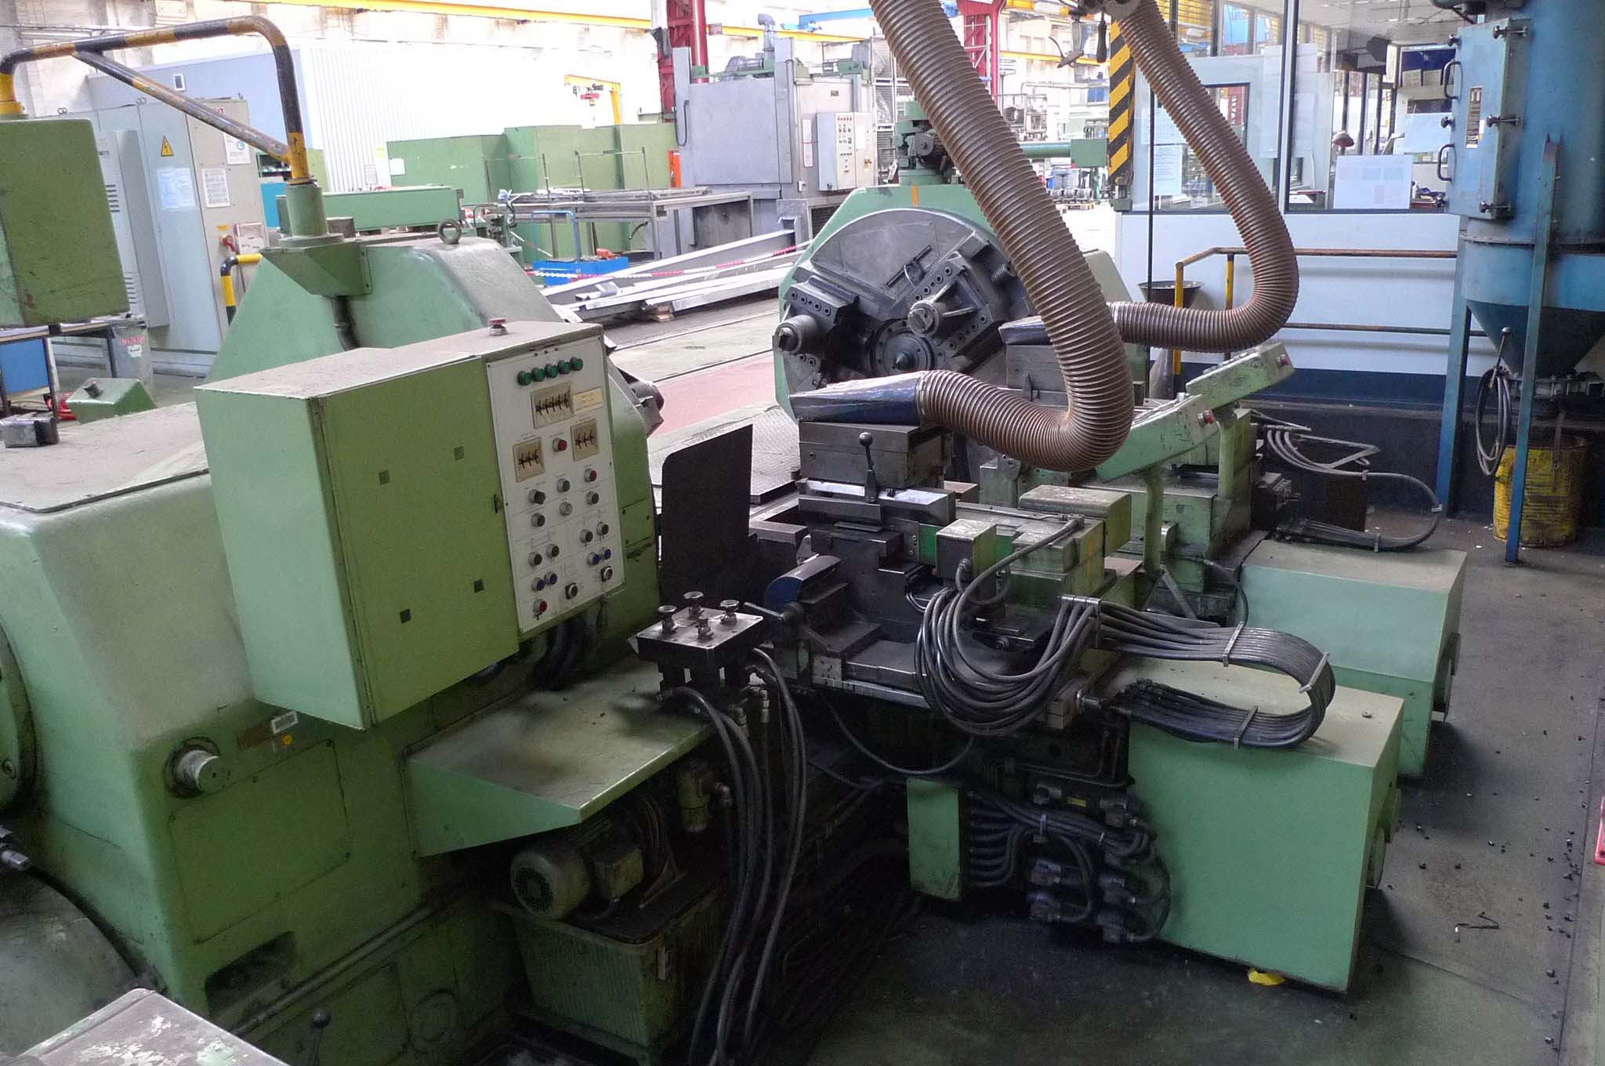
- Max. axle length wheel set: 2.350
- Min. axle length wheel set: 2.050

- Max. clamping Ø. : 1.050
- Min. clamping Ø. : 700

- Face plate Ø. : 1.400

- Speeds.
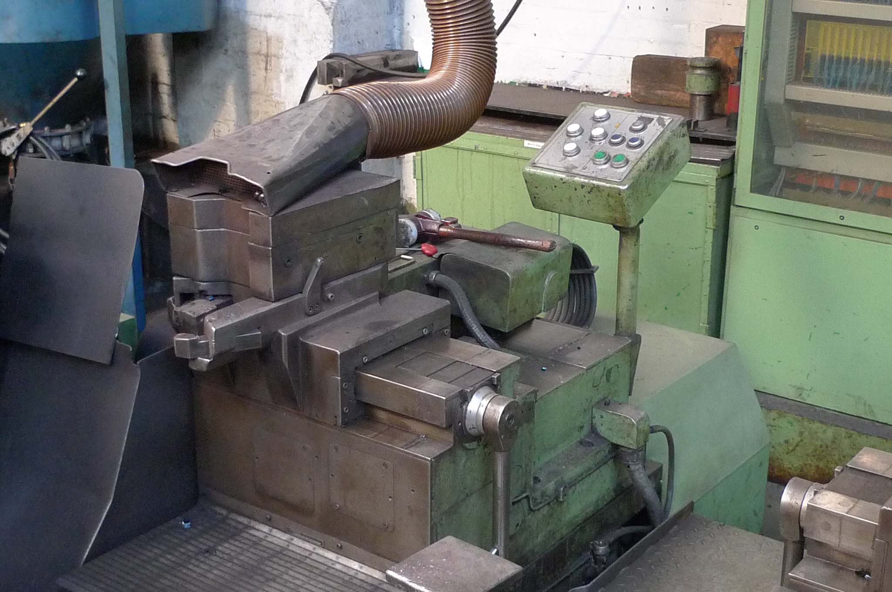
- Ø. Of headstock quills :

- Overall length bed :
- Width across bed sideways :
- Height of bed to floor :

- Power. 400 V / 90 kW
- Weight. Ca. 40 tonn

Please Note: The above information has been obtained to the best of our ability and belief from, and from the manufacturers where possible. It is given in good faith, but its accuracy can not be guaranteed. Accordingly, it will not form a representation or constitute contractual terms. We advise you to check any vital details!

