MACH4METAL

metalworking machinery
Transito 21, 6909 DA Babberich, Netherlands
Tel. + 31 (0)316 – 247123
Fax. + 31 (0)316 - 247956
info@mach4metal.com
www.mach4metal.com
Bank No : 66.52.13.883
IBAN : NL33 INGB 0665 2138 83
BIC : INGBNL2A
VAT : NL 815393635B01

HEAVY DUTY Profile bender
Hydraulic SCHAFER

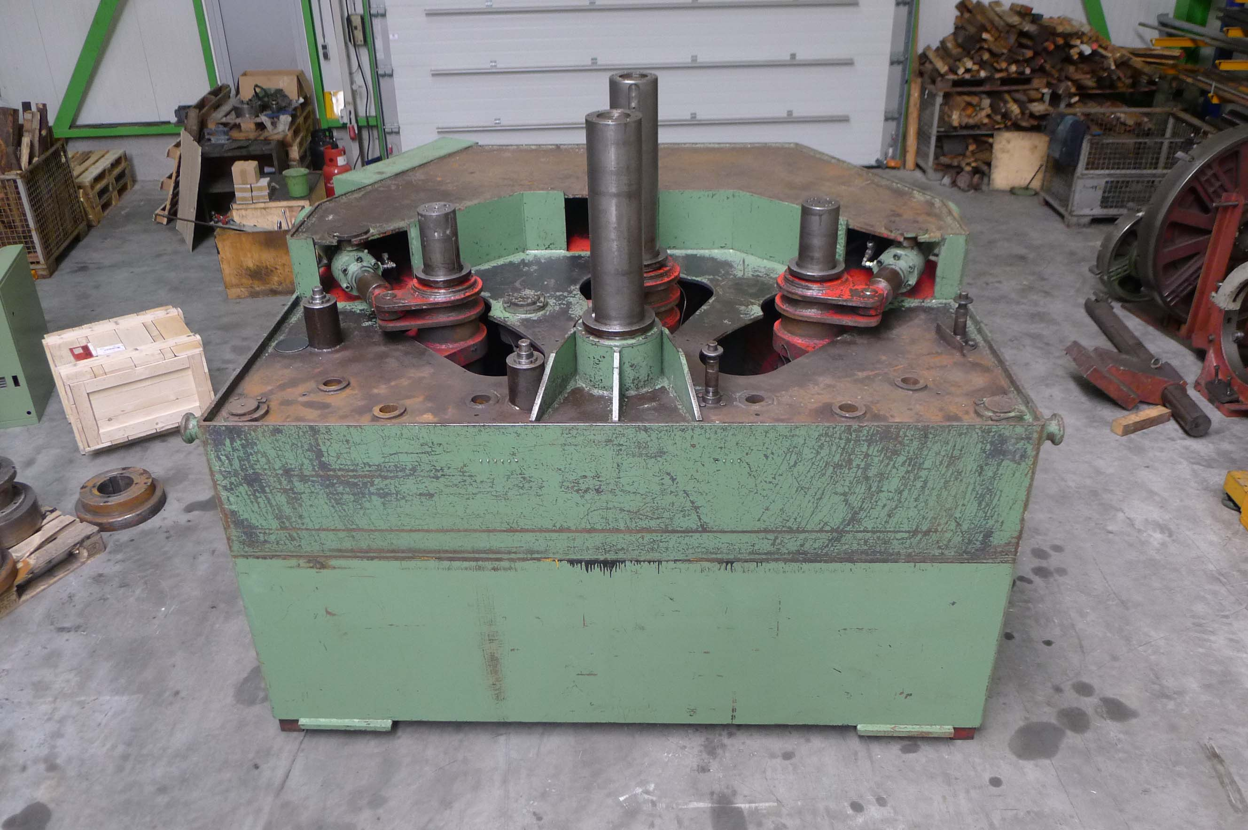
- Make : Schafer Germany
- Type : SPVRM 65 / 140
- Age : 1974
- Mach. No : 9230001

- Shaft Ø : 200 mm
- Roll Ø : 400 mm
- Shaft length :
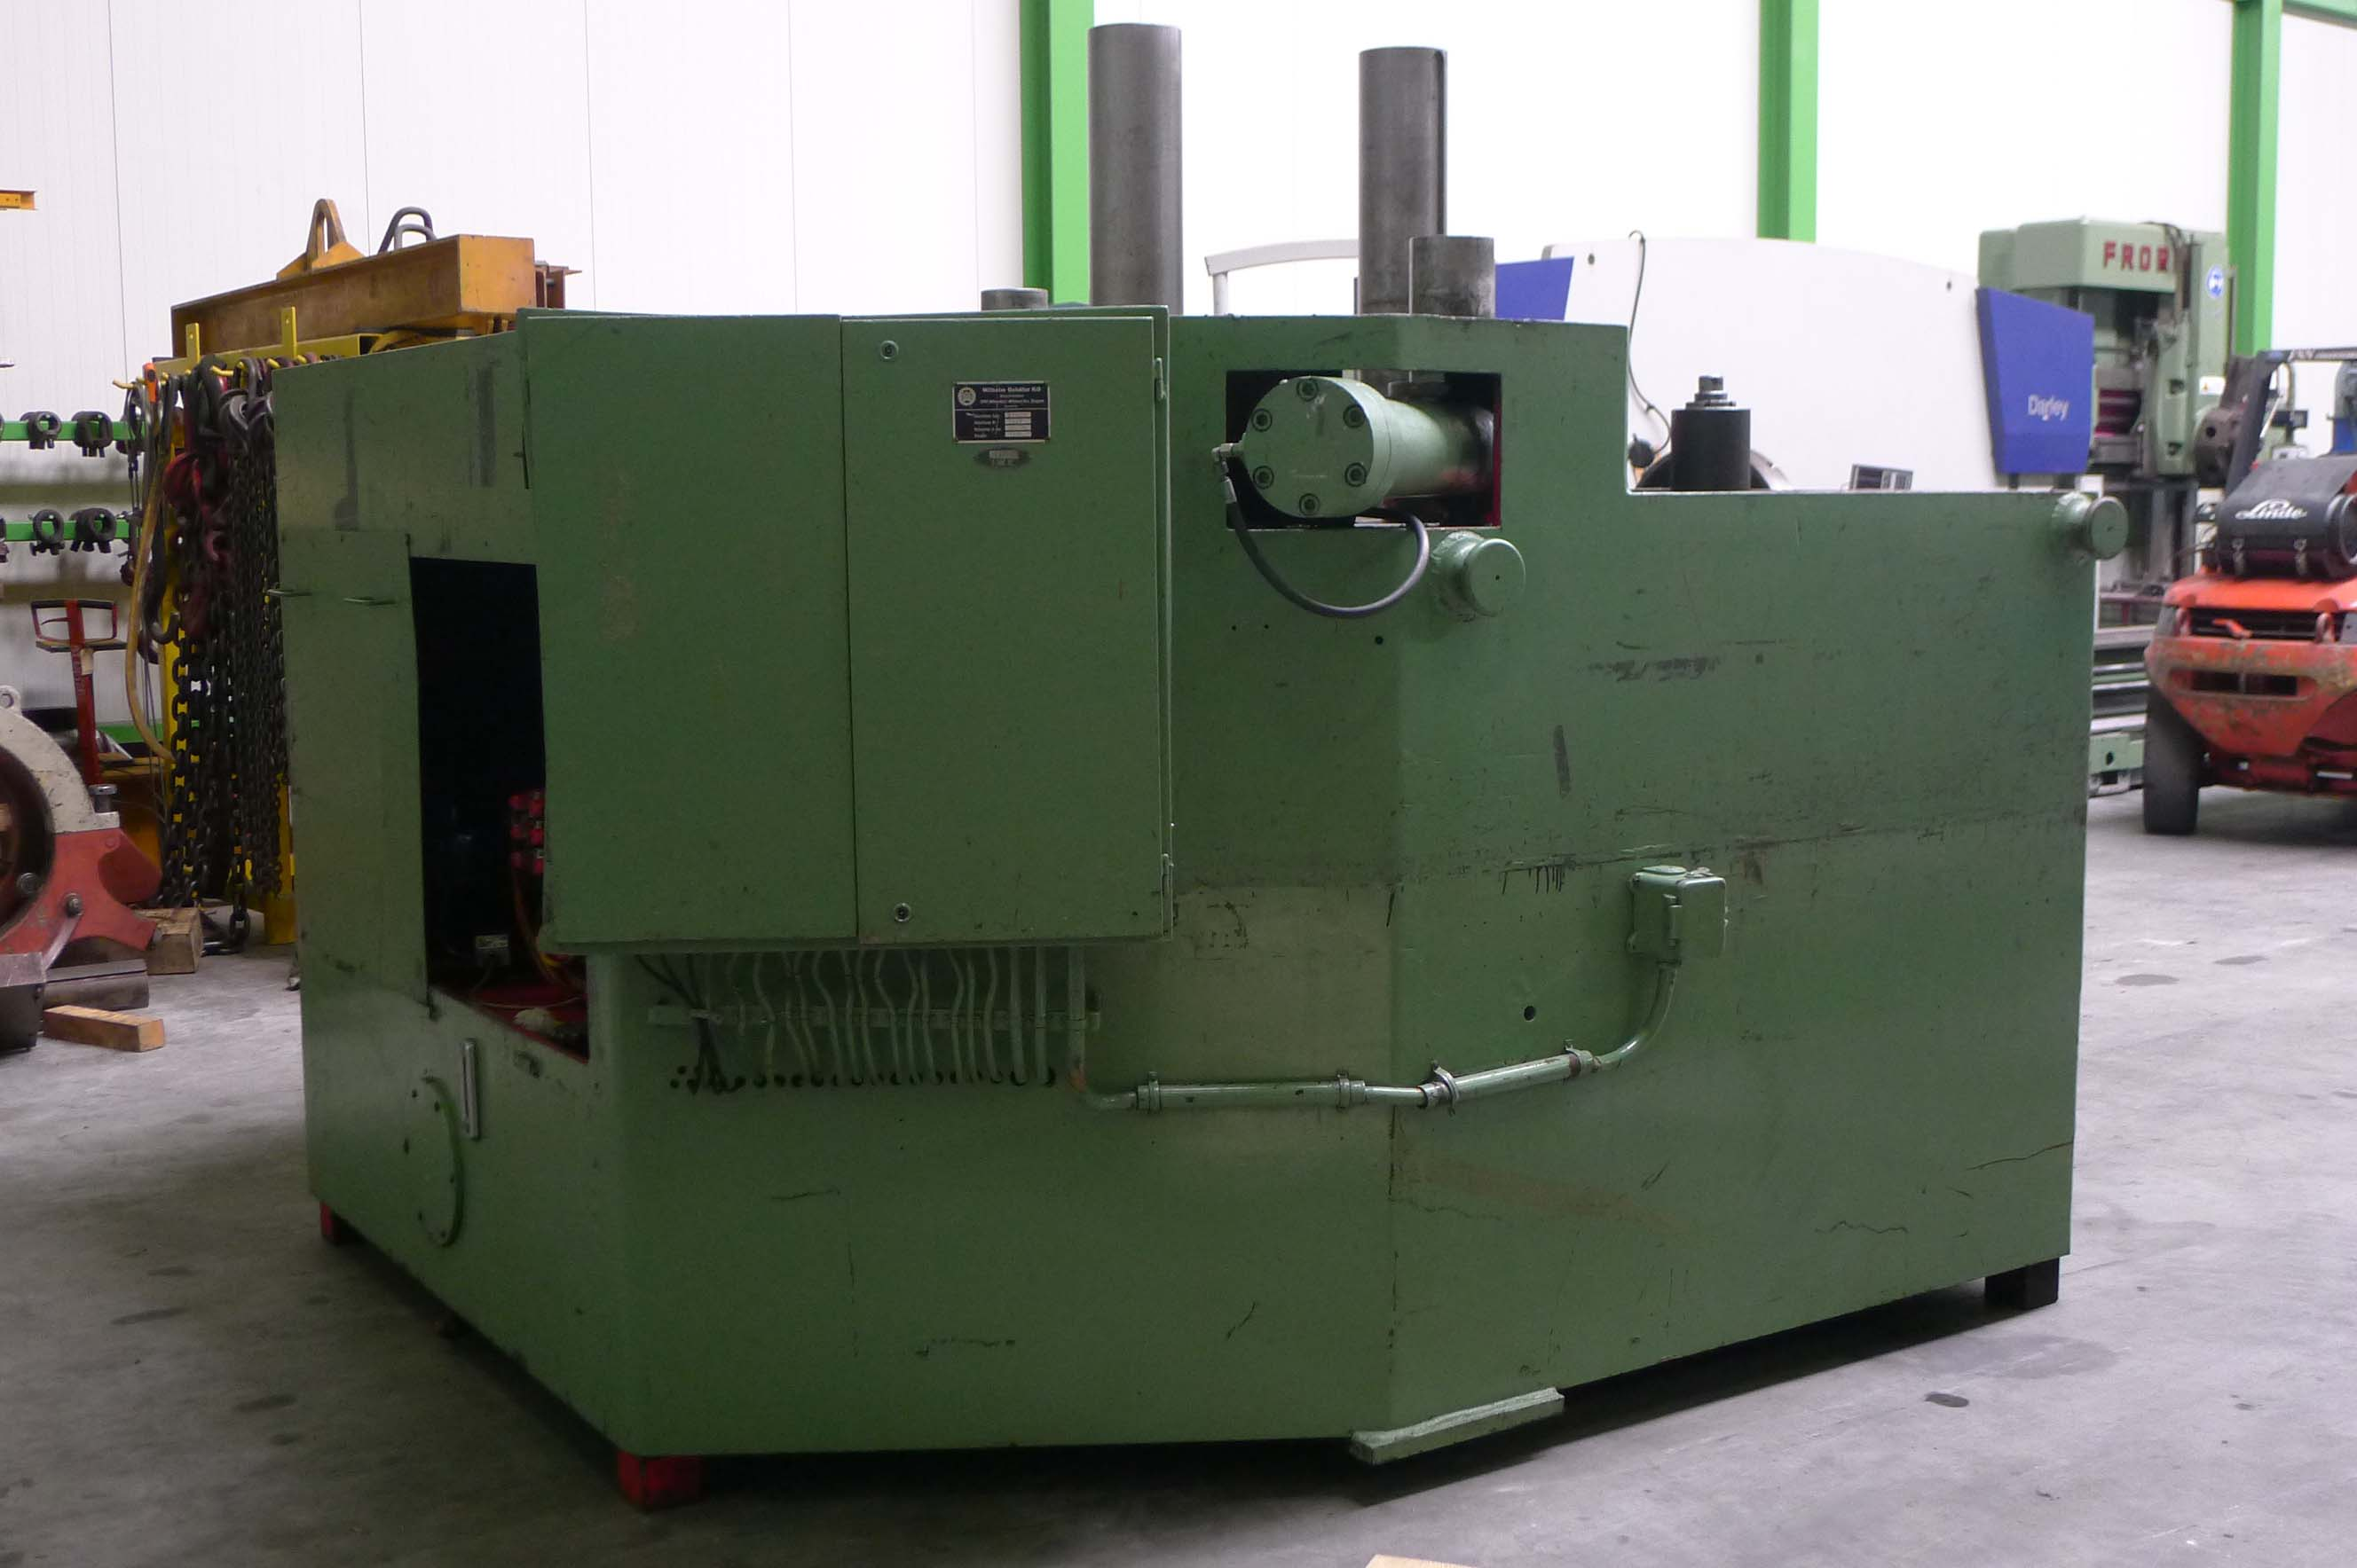
- U Profile : U 280
- I Profile : I 280
- Angle : 140 x 140 x 13
- T : 140 x 140 x 15
- Flatt high side : 125 x 25 mm
- Tube : Ø 120 x 6 mm

- Working speed : 0 – 10 M/Min
- Positioning speed : 250 MM/Min
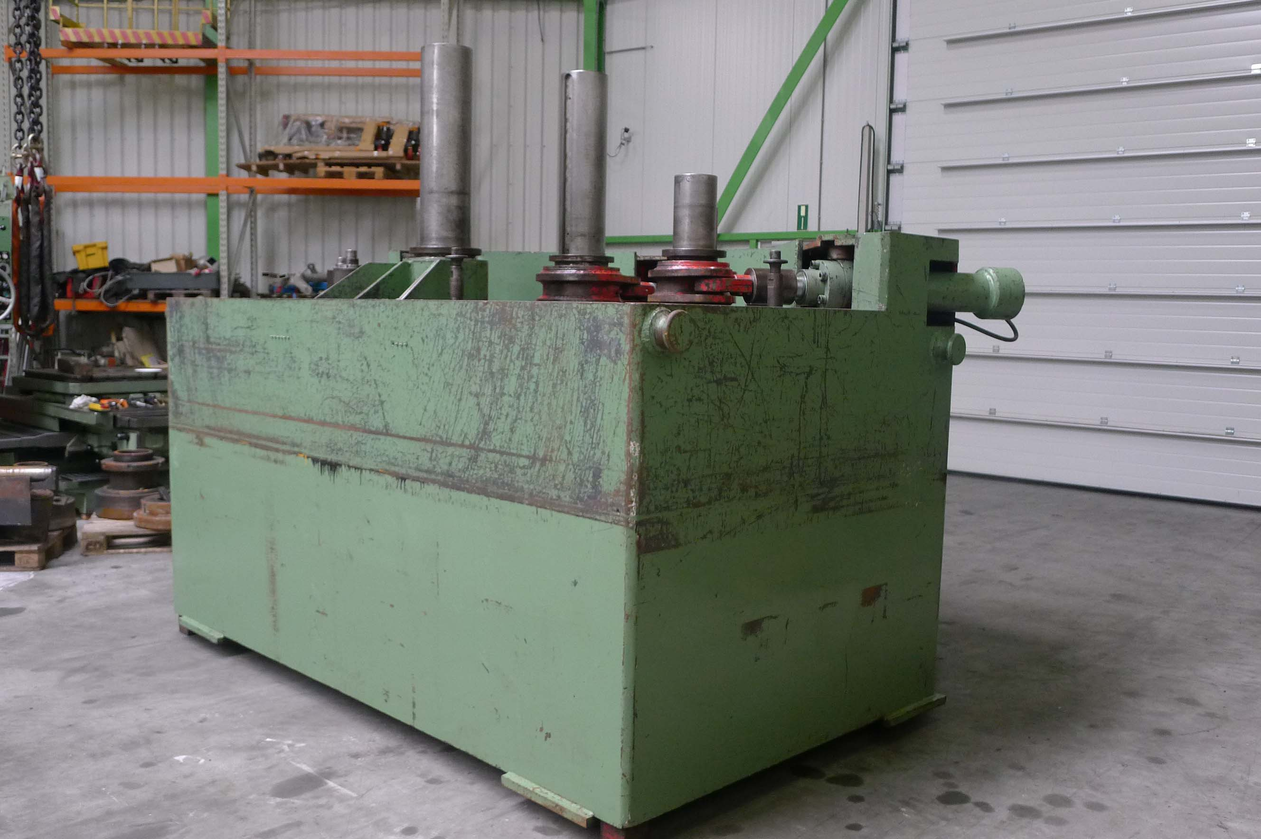
- Adjustment rolls : 450 / 600 mm
- Working pressure : 20.000 Kp

- Power 380 V / 30 kW
- Dimensions
- Length : 3.300
- Width : 3.700
- Height : 2.600
- Weight : 15 T

- 1 fixed roll and 3 adjustable rolls
- Digital readout position rolls

Please Note: The above information has been obtained to the best of our ability and belief from, and from the manufacturers where possible. It is given in good faith, but its accuracy can not be guaranteed. Accordingly, it will not form a representation or constitute contractual terms. We advise you to check any vital details!

