MACH4METAL

metalworking machinery
Transito 21
6909 DA BABBERICH Netherlands
Tel. +31 (0)316-247123
Fax: +31 (0)316-247956
info@mach4metal.com
www.mach4metal.com

Bank No : 66.52.13.883
IBAN : NL33 INGB 0665 2138 83
BIC : INGBNL2A

CNC Pressbrake DARLEY EHP 340

- Merk : Darley Holland
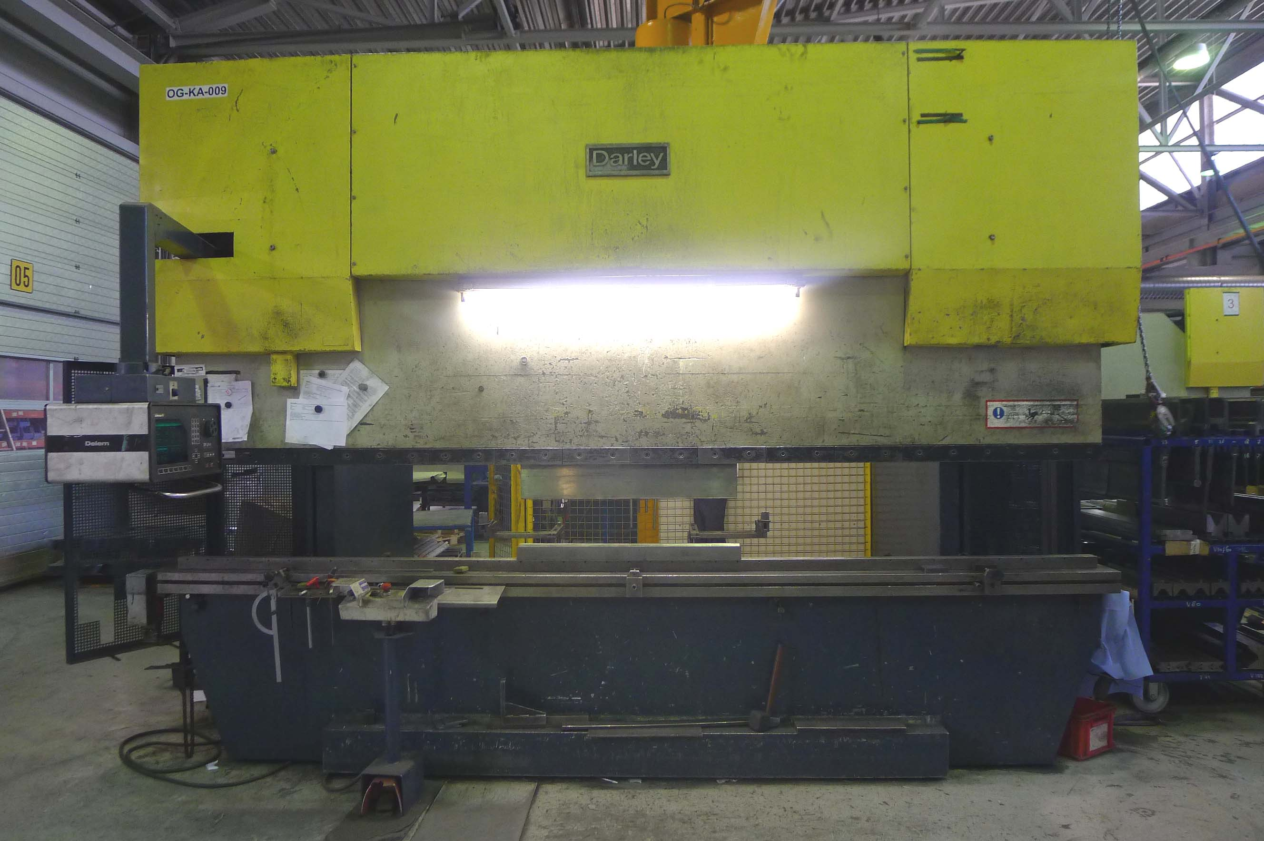
- Type : EHP 340 43/31
- Mach.No : 12.1783
- Yom : 1996

- Max. bending length : 4.300
- Between column : 3.100
- Max. force Kn : 3.400
- Troath : 400
- Max. stroke : 300
- Die height : 525
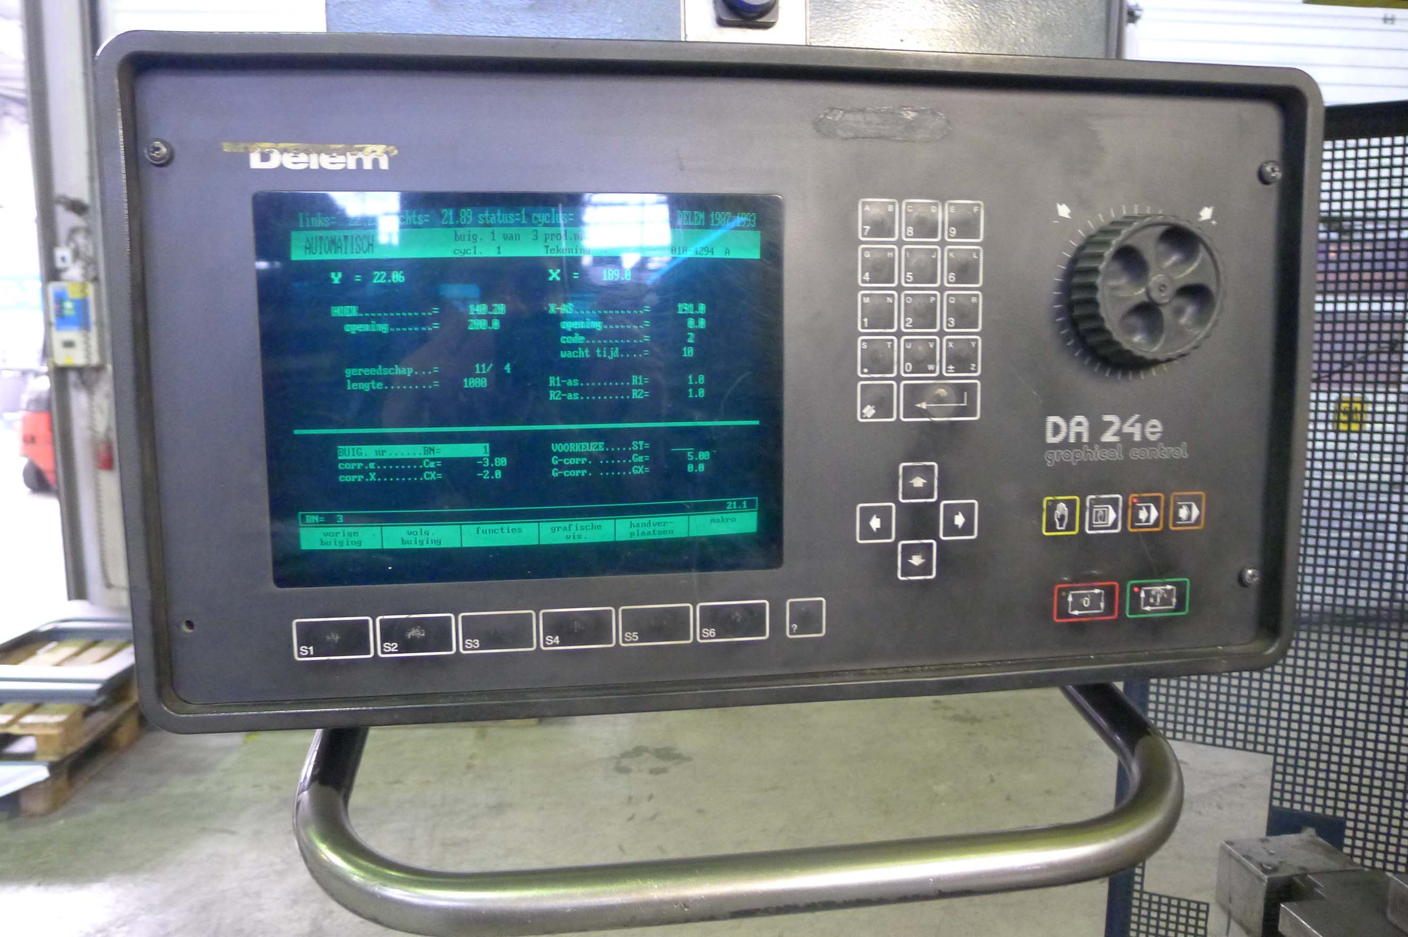
- Approch speed : 100 mm/sec.
- Pressing speed : 10 mm/sec.
- Return speed : 100 mm/sec.

- CNC Delem DA 24 E – 6 Axis
- Y1/Y2/X/R1/R2/V-Crowning

- Upper & Lower tool clamping by hand
- Documentation
- sheet arms front side (hand)
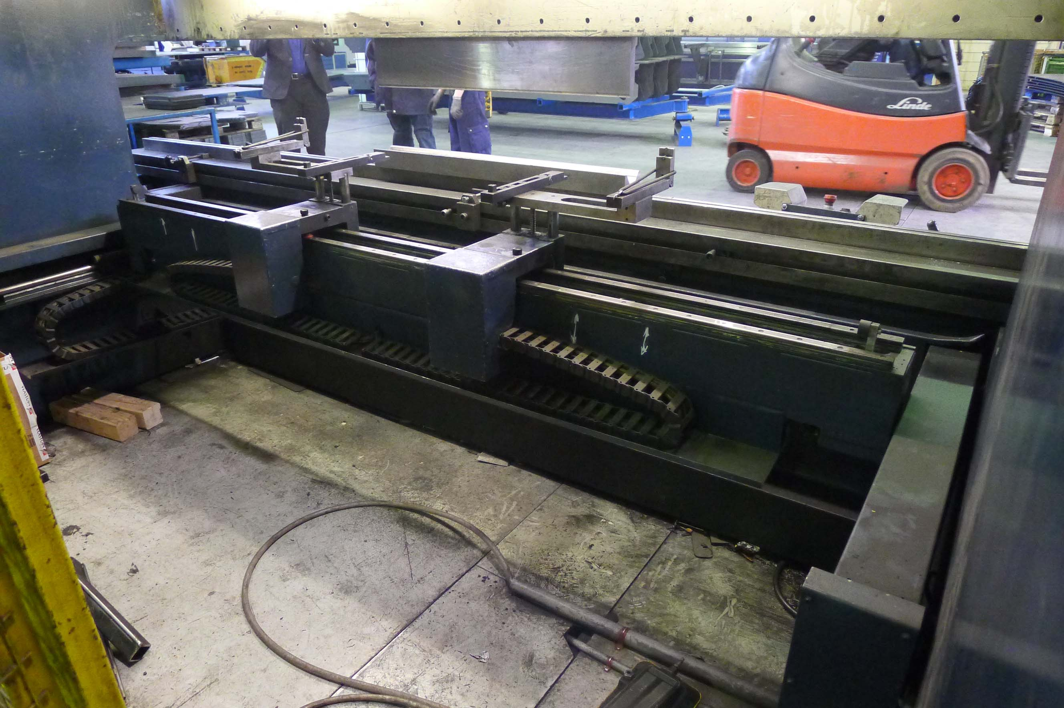

- Power : 400 V / 23,7 kW
- Length : 4.520
- Width : 2.200
- Height : 3.200
- Weight : 29.000

- Top tool ?
- Lower tool ?

Please Note: The above information has been obtained to the best of our ability and belief from, and from the manufacturers where possible. It is given in good faith, but its accuracy can not be guaranteed. Accordingly, it will not form a representation or constitute contractual terms. We advise you to check any vital details!

