MACH4METAL

metalworking machinery
Transito 21
6909 DA BABBERICH Netherlands
Tel. +31 (0)316-247123
Fax: +31 (0)316-247956
info@mach4metal.com
www.mach4metal.com

Bank No : 66.52.13.883
IBAN : NL33 INGB 0665 2138 83
BIC : INGBNL2A

I.MA.L CNC Pressbrake 10100 x 420
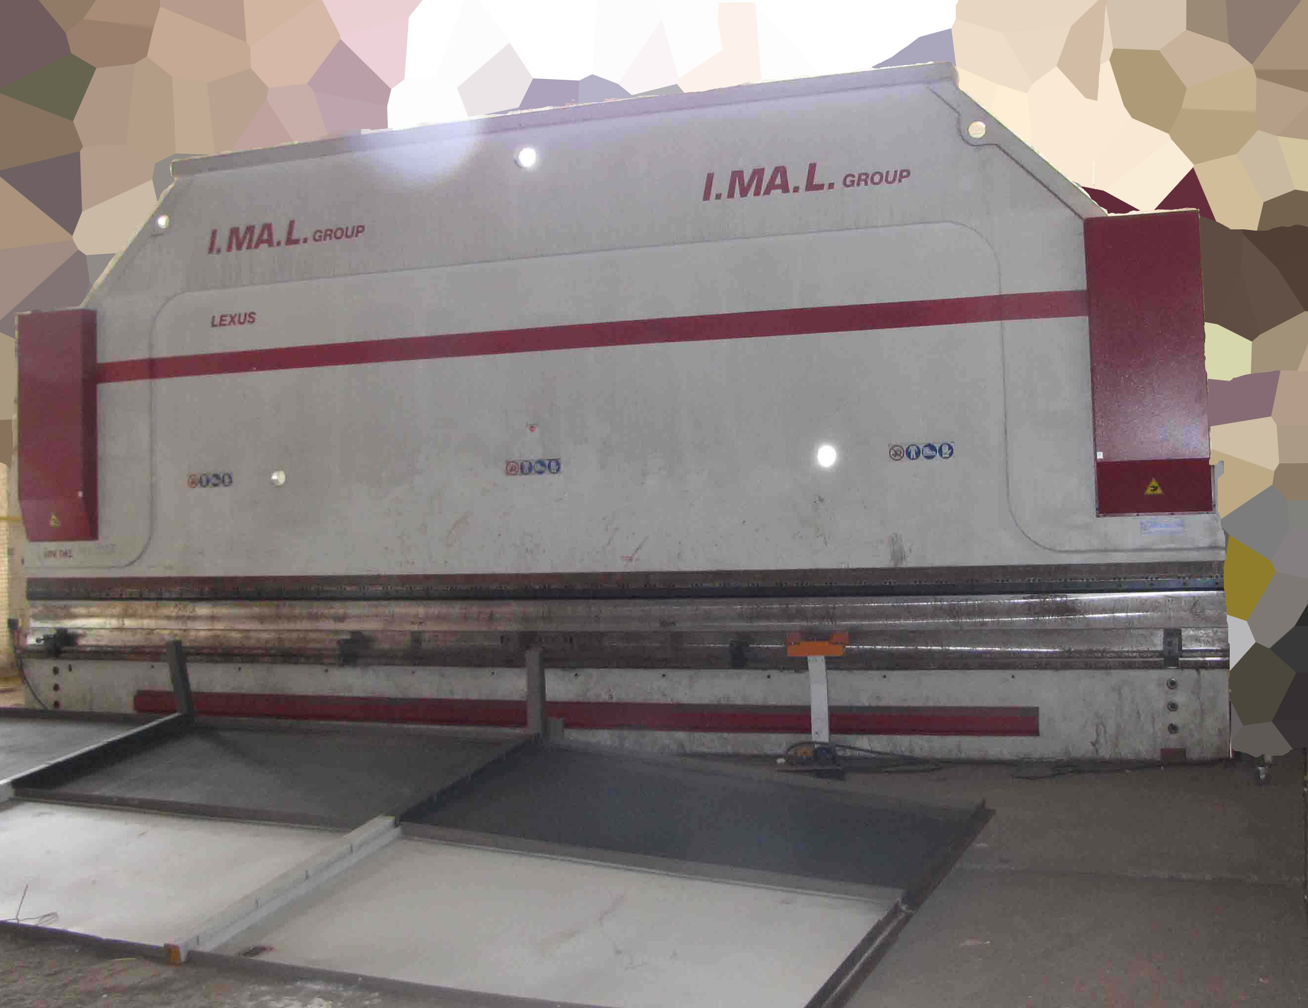
- Make : I.MA.L - Italia
- Typ : L 420 / 101
- Mach.No : 020634
- Yop : 2000

- Max. bending length : 10.100 mm
- Between housing : 9.000 mm
- Max. pressure : 420 ton

- Depth of throat : 510 mm
- Beam stroke : 350 mm
- Max. Adj. beam : 350 mm
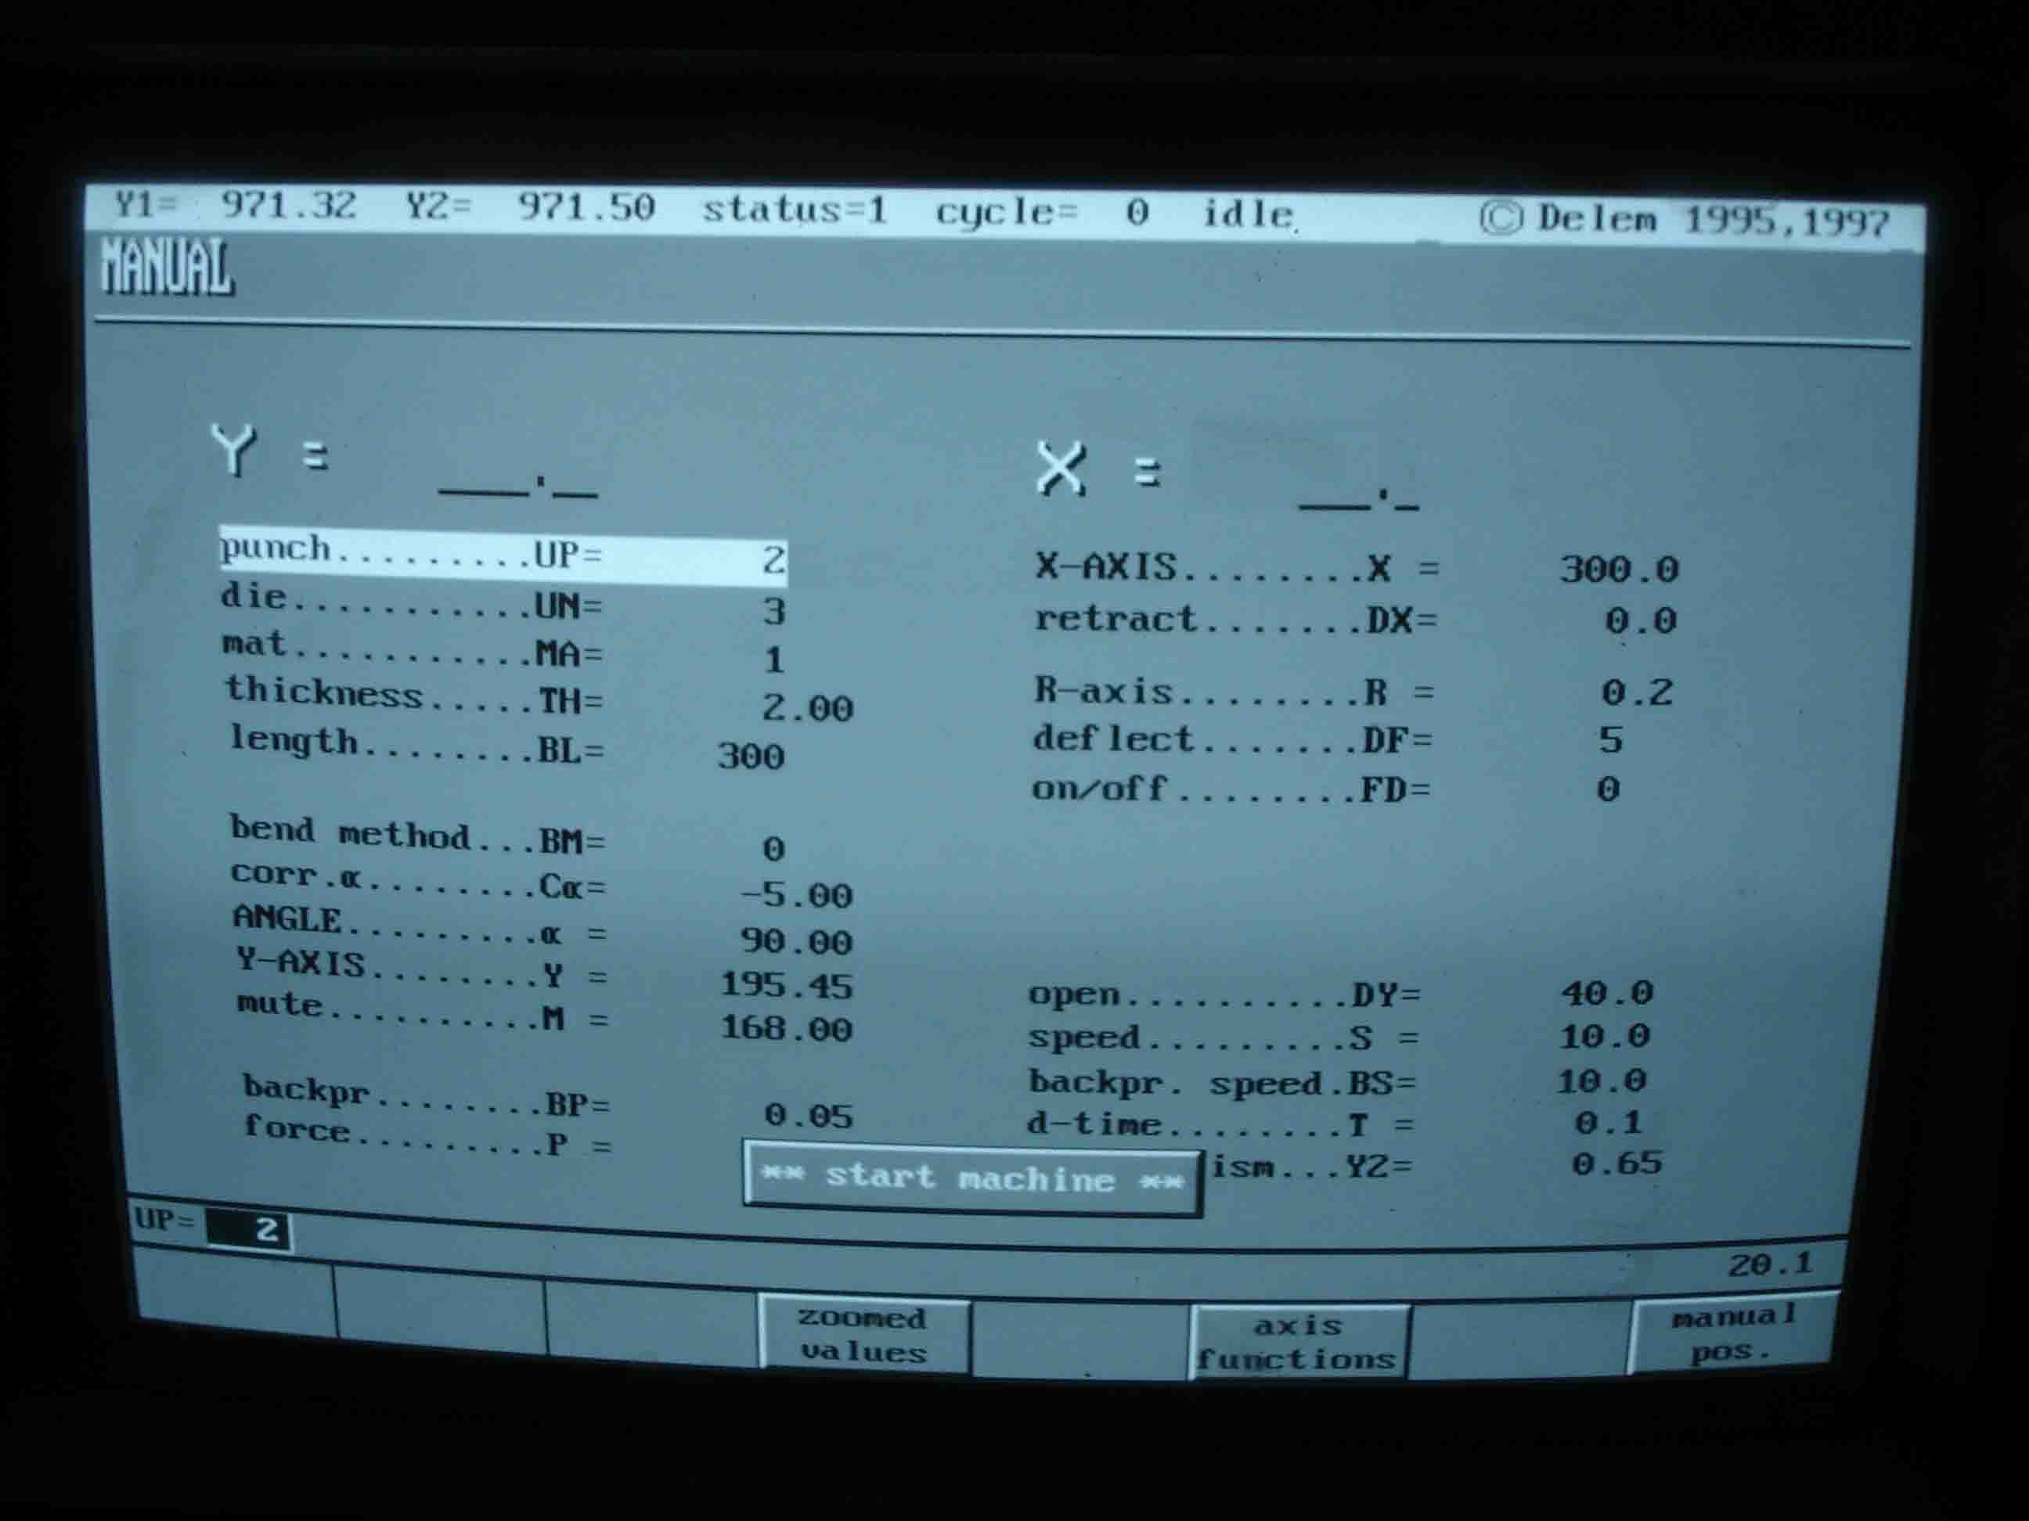
- Dis. Beam – table : 600 mm
- Table width : 320 mm

- Approch speed : 100 mm/min
- Bending speed : 10 mm/min
- Return speed : 70 mm/min

- CNC Controll DELEM DA 65
- Y1 / Y2 / X(800) / R(150) / Crowning

- Power 400 V / 35 kW
- Dimensions
- Lenght : 10.900
- Width : 2.550
- Height : 5.100 over floor
- Embedded : 1.900
- Weight : 85.500 Kg

- 2 sets off tooling SAE 1080 2 x 5050 mm

Please Note: The above information has been obtained to the best of our ability and belief from, and from the manufacturers where possible. It is given in good faith, but its accuracy can not be guaranteed. Accordingly, it will not form a representation or constitute contractual terms. We advise you to check any vital details!

